IEAGHG Information Paper: 2016-IP25; CO₂ emissions in 2015 – 65th BP Statistical Review
BP reported that emissions of CO₂ from energy consumption increased by only 0.1% in 2015. This was according to BP, this was the smallest increase in annual emissions since 1992 excepting the one off decline during the financial crisis of 2009.
The BP review indicates that the two largest reductions in emissions were from the US (-145.5 Mt, -2.6%) and Russia (-64.4 Mt, -4.2%). Other countries showing annual declines in their emissions were, Ukraine, Japan, Brazil and Canada. Emissions from China were also lower (-11.6 Mt, -0.1%), having declined for the first time since 1998.
For the US this is the sixth time in the last decade that it has had the largest decline in CO₂ emissions in the world. The decline in CO₂ emissions in the US now takes it back to its 2012 levels, and nearly 10.5% lower than its peak in 2007.
Japan is nearly back to its pre-Fukushima levels (2% higher than in 2010), while Ukraine’s emissions Aare the lowest on record since the breakup of the USSR.
Despite all these positive declines some countries are still increasing their emissions. The biggest increase in emissions came from India (112.4 Mt, 5.3%) for the second successive year, and three and a half times larger than the next biggest increase (Saudi Arabia, 32.1 Mt, 5.4%). EU emissions also rose for the first time since 2010 (+43.6 Mt Leading the increase in EU emissions were Spain (18.5 Mt, 6.8%) and Italy (16.5 Mt, 5.1%).
For further details go to: http://www.bp.com/en/global/corporate/energy-economics/statistical-review-of-world-energy/co2-emissions.html
Carbon dioxide emissions, MT CO₂

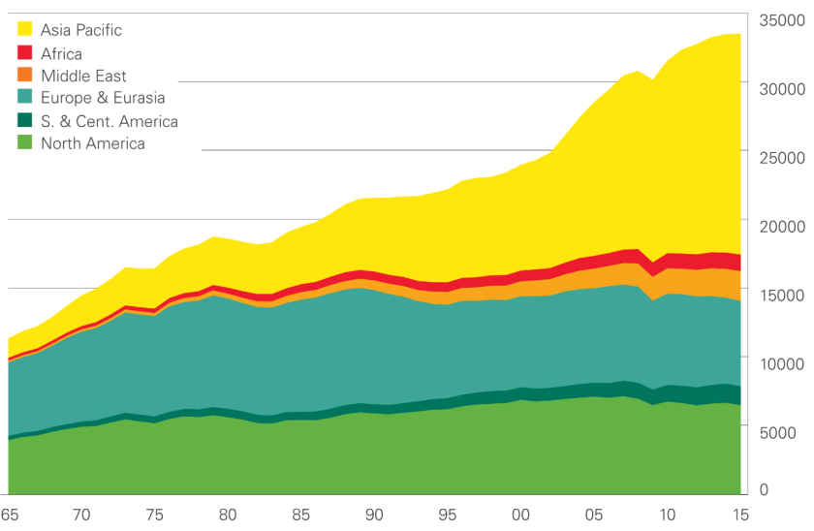
Source: BP Statistical Review of World Energy June 2016, bp.com/statisticalreview #BPstats

