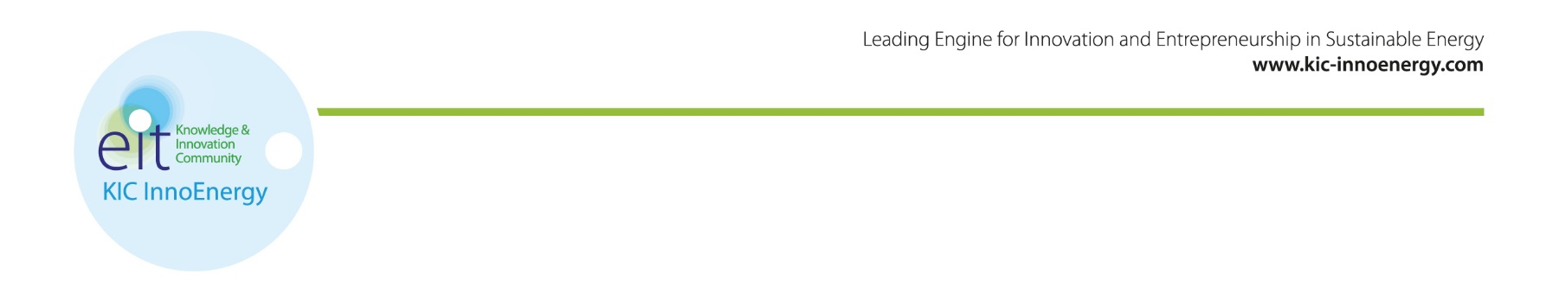

Application for KIC InnoEnergy PhD School open until February 14th
Is your PhD project in the field of Energy? connected with an industrial issue or company? Are you interested in developing a product or service related to your research? If so, apply to KIC InnoEnergy PhD School programme.
KIC InnoEnergy offers a training programme that compliments and supplements the regular doctoral studies, independently completed at their home university.
The benefits for you are:
Access to a network of 220 partners in Europe through participation in scientist conferences and network events with all expenses covered by KIC InnoEnergy.
Training in innovation, entrepreneurship and business to supplement technical skills and increasing employment possibilities for graduates.
International mobility – Expenses for travel, accommodation and allowance covered by KIC InnoEnergy.
The benefits for your supervisors in the laboratory or in the company are:
Reinforced efficiency in collaborative research thanks to the presence of a relevant actor trained in innovation, entrepreneurship and business and well involved in the KIC InnoEnergy industrial network
Reinforced efficiency in international collaboration thanks to the PhD candidate’s international mobility fully funded by KIC InnoEnergy (4-12 months)
The application is open for PhD candidates that are enrolled or accepted to a PhD position. Contact details and information about admission and selection can be found below.
Get in touch with us http://www.kic-innoenergy.com/to find out more!
Isabelle Schuster, PhD School Coordinator
phdschool@kic-innoenergy.com

Important dates
Winter Assessment:
February 14th – Last application date for the winter round
March 10^{th,} 11th – Face-to-face interview in Leuven, Belgium
End of March: final decision

Spring Assessment:
May 22nd - Last application date for the spring round
June 16th, 17th – Face-to-face interview
End of June: final decision

Autumn Assessment:
October 25th: - Last application date for the spring round
November 15th, 16th – Face-to-face interview
End of November: final decision

Application documents, Admission and selection criteria
www.kic-innoenergy.com/education/phd-school/application/
- Clean Coal Technologies
- Energy Efficiency
- Energy from Chemical Fuels
- Electricity Storage
- Renewable Energies
- Smart and Efficient building and cities
- Smart Electric Grid
- Sustainable Nuclear and Renewable Convergence
The application is open all-year-round with 3 assessments per year in October, February and May.

