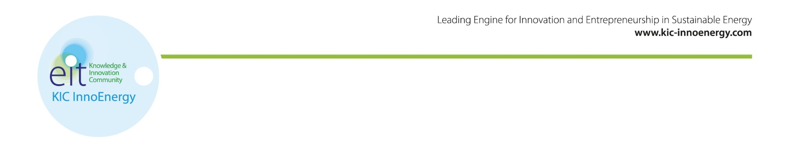

KIC InnoEnergy PhD School: next assessment June 2015, the 15th
Do you know PhD candidates who want to develop a product or service related to their research leaded within collaboration with industry? If so, you should encourage them to apply until June 2015, the 15th.
We offer an innovation oriented programme that compliments and supplements the regular doctoral studies, independently completed at their home university.
The benefit for the PhD - students are:
Access to a network of 220 partners in Europe through participation in scientist conferences and network events with all expenses covered by KIC InnoEnergy.
Training in innovation, entrepreneurship and business to supplement technical skills and increasing employment possibilities for graduates.
International mobility – Expenses for travel, accommodation and allowance covered by KIC InnoEnergy.

The benefits for the supporting company are:
Reinforced efficiency in collaborative research with laboratories thanks to the presence of a relevant actor trained in innovation, entrepreneurship and business
Reinforced efficiency in innovation thanks to the presence of an expert well aware of the industry and market challenges
Reinforced efficiency in international development thanks to the PhD student’s international mobility fully funded by KIC InnoEnergy (4-12 months)
The application is open for PhD candidates that are enrolled or accepted to a PhD position. The CIFRE framework is particularly targeted by the programme.
Contact details and information about admission and selection can be found below.
Get in touch with us to find out more!
Isabelle Schuster, PhD School Coordinator
phdschool@kic-innoenergy.com

Winter Assessment:
February 14th – Last application date for the winter round
March 10^{th,} 11th – Face-to-face interview in Leuven, Belgium
End of March: final decision

Spring Assessment:
May 22nd - Last application date for the spring round
June 16th, 17th – Face-to-face interview
End of June: final decision

Autumn Assessment:
October 25th: - Last application date for the spring round
November 15th, 16th – Face-to-face interview
End of November: final decision

Application documents
www.kic-innoenergy.com/education/phd-school/application/application-documents-and-structures/
Admission and selection criteria
www.kic-innoenergy.com/education/phd-school/application/admission-and-selection-criteria/

- Clean Coal Technologies
- Energy Efficiency
- Energy from Chemical Fuels
- Electricity Storage
- Renewable Energies
- Smart and Efficient building and cities
- Smart Electric Grid
- Sustainable Nuclear and Renewable Convergence

